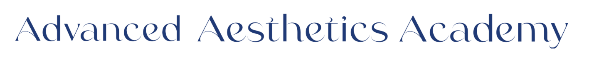
Future Student Welcome Packet

Dear Future Student,
Hello and welcome! My name is Heidi Daly, and I am the owner of Advanced Aesthetics Academy. I am thrilled that you are considering joining our esthetics program and taking the first step toward a rewarding career in the skincare and beauty industry.
Our 450-hour Esthetics Program is designed to give you the hands-on experience, knowledge, and confidence you need to succeed. From skincare treatments and facials to waxing and professional product use, our curriculum prepares you for licensure and real-world application.
At Advanced Aesthetics Academy, we pride ourselves on creating a supportive and inspiring environment. Our experienced instructors are passionate about helping students grow their skills and achieve their career goals. We are committed to providing the guidance and resources you need to thrive.
I invite you to explore our program, ask questions, and imagine the opportunities ahead. Becoming an esthetician is not just learning a trade—it’s launching a career where you can help others feel confident and cared for, all while doing work you love.
We hope to welcome you to Advanced Aesthetics Academy soon!
Warm regards,
Heidi Daly
Owner, Advanced Aesthetics Academy

1. 2026 Closing dates

• January 1-2nd, 2026 (Thursday-Friday) – New Year’s Day

• April 3 (Friday) – Good Friday

• April 13–19, 2026 (Monday–Friday) – Spring Break (Heritage Week)

• May 25, 2026 (Monday) – Memorial Day

• September 7, 2026 (Monday) – Labor Day

• November 25–29, 2026 (Wednesday–Sunday) – Thanksgiving

• December 23, 2026 – January 1, 2027 (Monday–Friday) –Winter Break

2. 2026 Class Start Dates
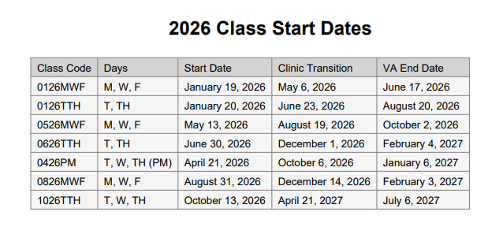

Enrollment ends 5 business days prior to class start date.

3. Personal Information
☐ Completed Enrollment Application
☐ Copy of Government-issued photo ID (driver’s license, passport, or state ID)
☐ Copy of Social Security card
☐ Uniform sizing Top:______ Bottoms: _________ Sweatshirt: _________

4. Required Documents
☐ High school diploma, GED, or transcripts (proof of completion of 10th Grade)
☐ Any required medical documentation, (if applicable)
☐ Lawful Presence (determines the status of the applicant's lawful presence in the United States)
Non-US Citizen Applicants
Anyone who completes their lawful verification form and is not a U.S. citizen must provide one of the acceptable documents listed below. The State Board requires this documentation in order to submit it to immigration.
- Students only need one of the documents from the list (not all).
- Immigration review takes approximately 1 month.
- Once immigration approves, it takes about 1 additional week for the State Board to receive the approval.
- After the State Board receives the approval, the student may schedule their exam.
If any of these below documents are in your possession, PLEASE PROVIDE A COPY OF ALL IMMIGRATION DOCUMENTS.
ACCEPTED IMMIGRATION DOCUMENTS:
- Unexpired Reentry Permit (I-327)
- Permanent Resident Card or Alien Registration Receipt Card With Photograph (I-551)
- Unexpired Refugee Travel Document (I-571)
- Machine Readable Immigrant Visa (with Temporary I-551 Language)
- Temporary I-551 Stamp (on passport or I-94)
- I-94 (Arrival/Departure Record) in Unexpired Foreign Passport
- I-20 (Certificate of Eligibility for Nonimmigrant, F-1, Student Status)
- DS2019 (Certificate of Eligibility for Exchange Visitor, J-1, Status)

5. Financial Requirements

Total Cost of Tuition: $13,500
Enrollment Deposit:
☐ Paid – $1,000
Tuition & Payment Options:
☐ Pay in Full Option (includes deposit + textbook fees $290)
  - 5% discount applied to tuition.
  - Total: $12,839.50
☐ Monthly Payment Plan Options (not including deposit):

  - Full-Time Day Classes (Mon-Wed-Fri, 9:00 AM – 5:00 PM):
    - $2,083.33/month × 6 months → Total: $12,500

  - Part-Time Day Classes (Tues-Thurs, 9:00 AM – 5:00 PM):
    - $1,562.50/month × 8 months → Total: $12,500

  - Part-Time Night Classes (Tues-Wed-Thurs, 5:30 PM – 9:30 PM):
    - $1,250/month × 10 months → Total: $12,500
- A larger deposit is always accepted if you’d like to lower your monthly payments.
☐ Signed financial agreement or contract
6. Tuition & Payment Policy
- Tuition invoices are emailed on the 25th and due by the 1st. Payments can be made by credit card, or by cash/check directly to Stacy. Students may request their balance at any time.
- Late or partial payments incur a $50 late fee, and students cannot attend class until paid in full, which may delay their training.
- Accounts that fall behind for three months (consecutive or not) will be sent to collections.
- Payments not received by the 6th place the student on academic hold, preventing attendance. Returned checks incur a $35 returned check fee plus a $50 late fee.
- Students must be current on tuition to continue progressing—this includes starting clinic hours, receiving completion paperwork, renting exam kits, ordering products, attending workshops, and qualifying for graduation.
7. Education & Class Expectations

Theory:
History and Career Opportunities The Treatment Room
The Healthy Professional Facial Devices and Technology
Communicating for Success Hair Removal
Infection Control Physiology/Histology
Beauty Business Chemical/Chemical Safety
Skin Analysis Skin Care, Product, Chem, Ingredients
Facial Massage Diseases & Disorder of the Skin
General Anatomy/Physiology Advanced Topics and Treatments
Make-up Essentials Life Skills
Your Professional Image Communicating for Success
Basics of Electricity Career Planning
On the Job Human Trafficking
Barbicide Skinny on Skin
Business Planning Salesmanship/Retailing

Hands-on/Clinicals
Customized Facials Skin Scrubber
Nano-Needle Facial Microdermabrasion Facial
Lash/ Brow Tinting Lash Lift/Brow Lamination
Dermaplaning Waxing (soft/Hard Wax)
Chemical Peels CryoClear
Micro-channeling Glo-Facial
Body Wraps Ergonomics for Estheticians
Massage Techniques Back Treatment
Men’s Facials Client Relations
And more…

• Mandatory Attendance: Students must maintain regular attendance; excessive absences may result in loss of benefits.
• Academic Progress: Students must maintain satisfactory academic progress as defined by the institution.
• Hands-On Training: Daily hands-on participation is required, as it is essential for developing esthetics skills.
• Exceptions: Exemptions from hands-on training are only allowed with a direct contraindication or a documented medical condition supported by a physicians note.
• Allergies & Reactions: Students must inform administration of any allergies or adverse reactions that may affect their ability to participate safely.
8. Future Career Opportunities

Day Spa Esthetician Medical Spa (Medi-Spa) Esthetician
Salon Esthetician Luxury Spa Specialist
Dermatology Assistant Laser Technician / Laser Hair Removal Specialist
Skin Care Therapist in Medical Clinics Oncology Esthetician
Makeup Artist / Bridal Makeup Artist Brow & Lash Technician
Waxing Specialist Permanent Makeup Artist
Skincare Product Consultant Brand Representative / Educator
Cosmetic Sales Specialist Self-Employed / Mobile Esthetician
Spa Owner / Manager Beauty Blogger / Influencer
Trainer / Educator Medical Esthetic Consultant
Cryotherapy /Wellness Center Specialist Esthetic Researcher / Product Developer

9. Points of Contact

Phone Number 843-784-3376

Heidi Daly, IES
Owner / CEO / Licensed Esthetics Instructor
📧 Heidi@A3Spa.com
Melissa Garbutt
Chief Operating Officer (COO) / Licensed Esthetician
📧 Melissa@A3Spa.com
Rebekah Esquivel
Admissions and Enrollment Manager / Licensed Esthetician
📧 Admissions@A3Spa.com

10. Licensing Disclaimer
Our school does not issue esthetics licenses. We provide comprehensive training in accordance with SCLLR esthetics regulations, ensuring students gain the knowledge and skills required for licensure. Upon completion of the 450-hour program and full payment of tuition, our staff will assist students by uploading the necessary documentation to SCLLR, making them eligible to apply for their esthetics license.
$45 application fee paid directly to the state licensing agency.
Licensing exams are administered by Prov Exams (third-party testing company):
Theory exam: $78
Practical exam: $89
Fees are payable directly to Prov Exams.

